Usage Statistics for snydersstoughton.com
Summary Period: Last 12 Months
Generated 21-Apr-2008 01:38 EDT

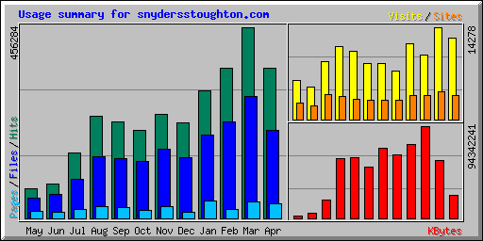
Summary by Month
Month | Daily Avg |  |  |  | Monthly Totals
Month | Hits | Files | Pages | Visits | Sites | KBytes | Visits | Pages | Files | Hits
Apr 2008 | 17023 | 9958 | 1706 | 597 | 3782 | 23295543 | 12546 | 35844 | 209135 | 357486
Mar 2008 | 14718 | 9412 | 1275 | 460 | 4358 | 58775996 | 14278 | 39543 | 291786 | 456284
Feb 2008 | 12368 | 7971 | 723 | 345 | 3739 | 94342241 | 10026 | 20982 | 231187 | 358699
Jan 2008 | 10124 | 6605 | 1389 | 389 | 3679 | 75359564 | 11688 | 41681 | 198167 | 303728
Dec 2007 | 7637 | 4859 | 514 | 247 | 2943 | 64538308 | 7436 | 15443 | 145773 | 229119
Nov 2007 | 8550 | 5697 | 949 | 297 | 3049 | 72006158 | 8627 | 27537 | 165235 | 247964
Oct 2007 | 7025 | 4541 | 669 | 288 | 3053 | 52940905 | 8660 | 20071 | 136256 | 210773
Sep 2007 | 7909 | 4930 | 910 | 365 | 3176 | 62152122 | 10594 | 26395 | 142975 | 229366
Aug 2007 | 7866 | 4750 | 892 | 366 | 3547 | 61208386 | 11357 | 27681 | 147252 | 243875
Jul 2007 | 5208 | 3123 | 719 | 296 | 3922 | 18696714 | 8898 | 21573 | 93693 | 156250
Jun 2007 | 3279 | 2296 | 556 | 199 | 2166 | 5225943 | 4996 | 13910 | 57415 | 81996
May 2007 | 2272 | 1594 | 507 | 195 | 2521 | 2336592 | 6070 | 15739 | 49415 | 70461
Totals |  |  |  |  |  | 590878472 | 115176 | 306399 | 1868289 | 2946001

Generated by Webalizer Version 2.01

